1. Portal - environment.ts – change link of WebApiBaseUrl

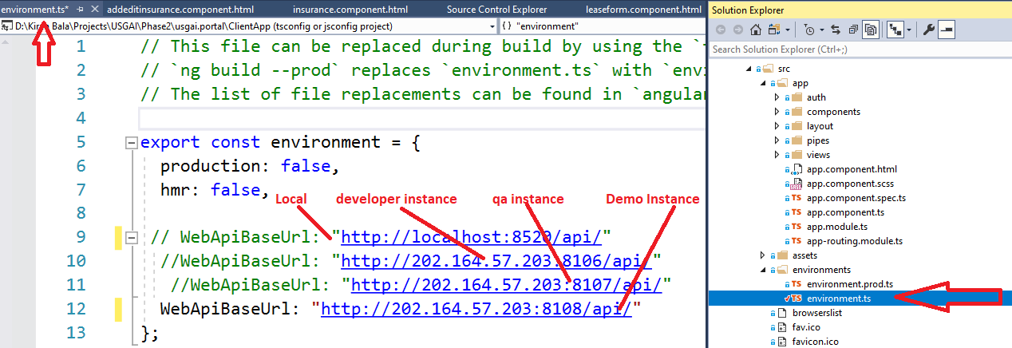

1. WebApi- appsettings.json  
   change Database name, Logo link and Site Link

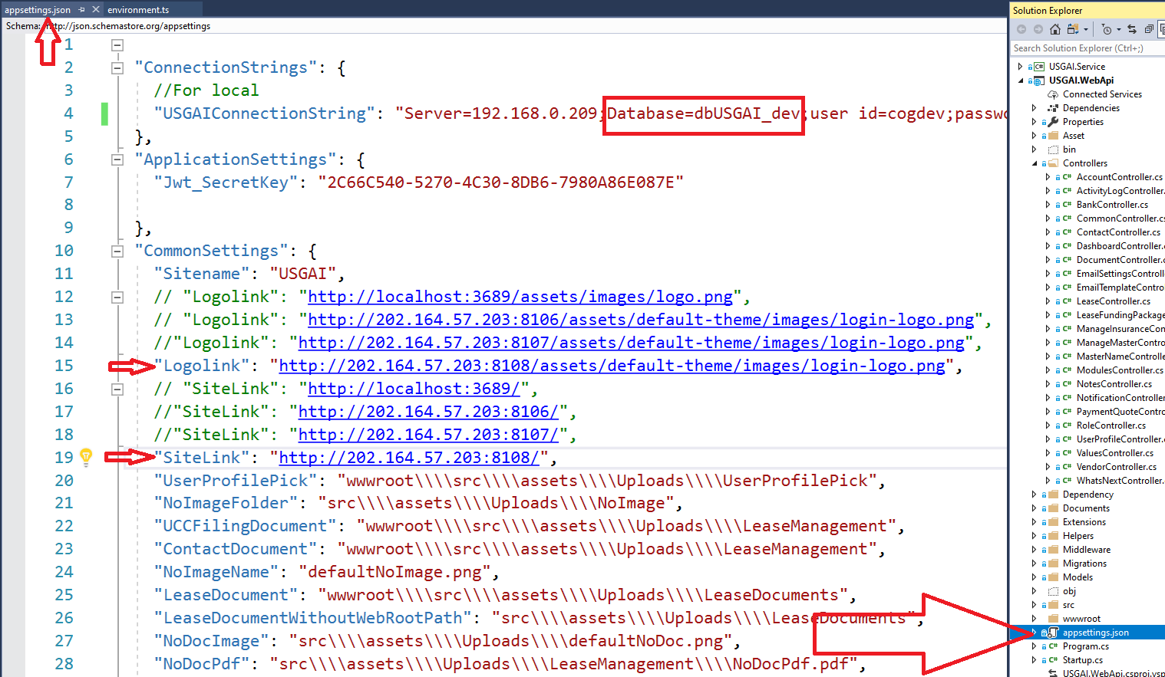

1. Build Project all the projects: Core, Repository, Service and Web Api

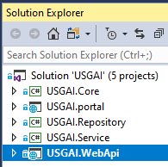

1. Build Portal

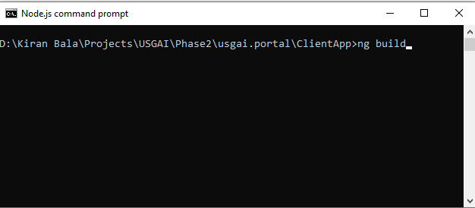

1. Public WebApi: Right click on WebApi folder and select Public.

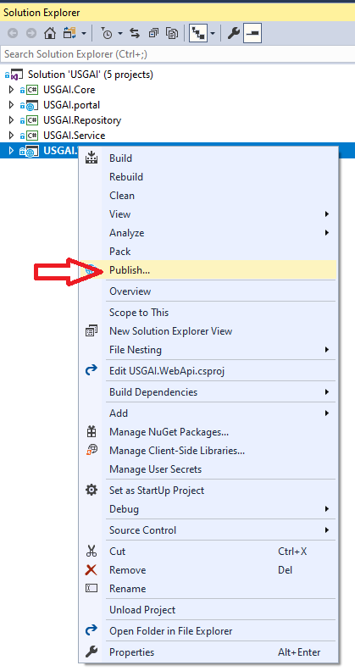

1. Below panel will be opened. Click on Public Button.

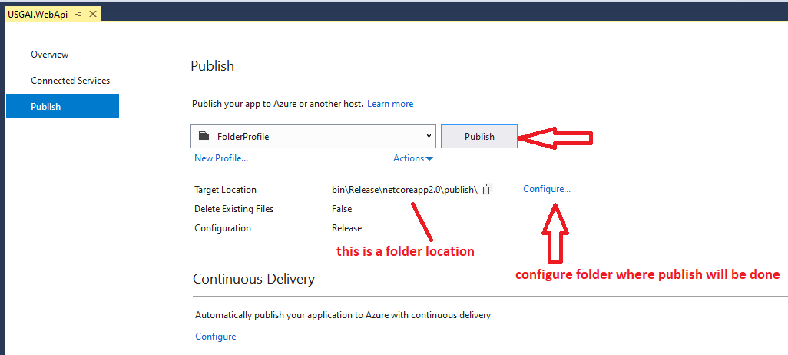

1. Publish success- below is a link of publish folder – open that folder

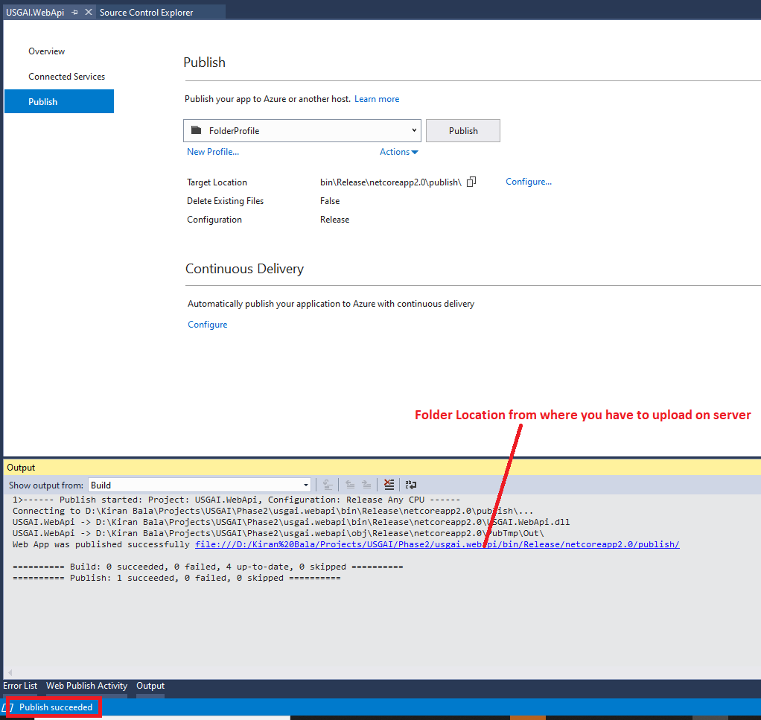

1. Public folder view

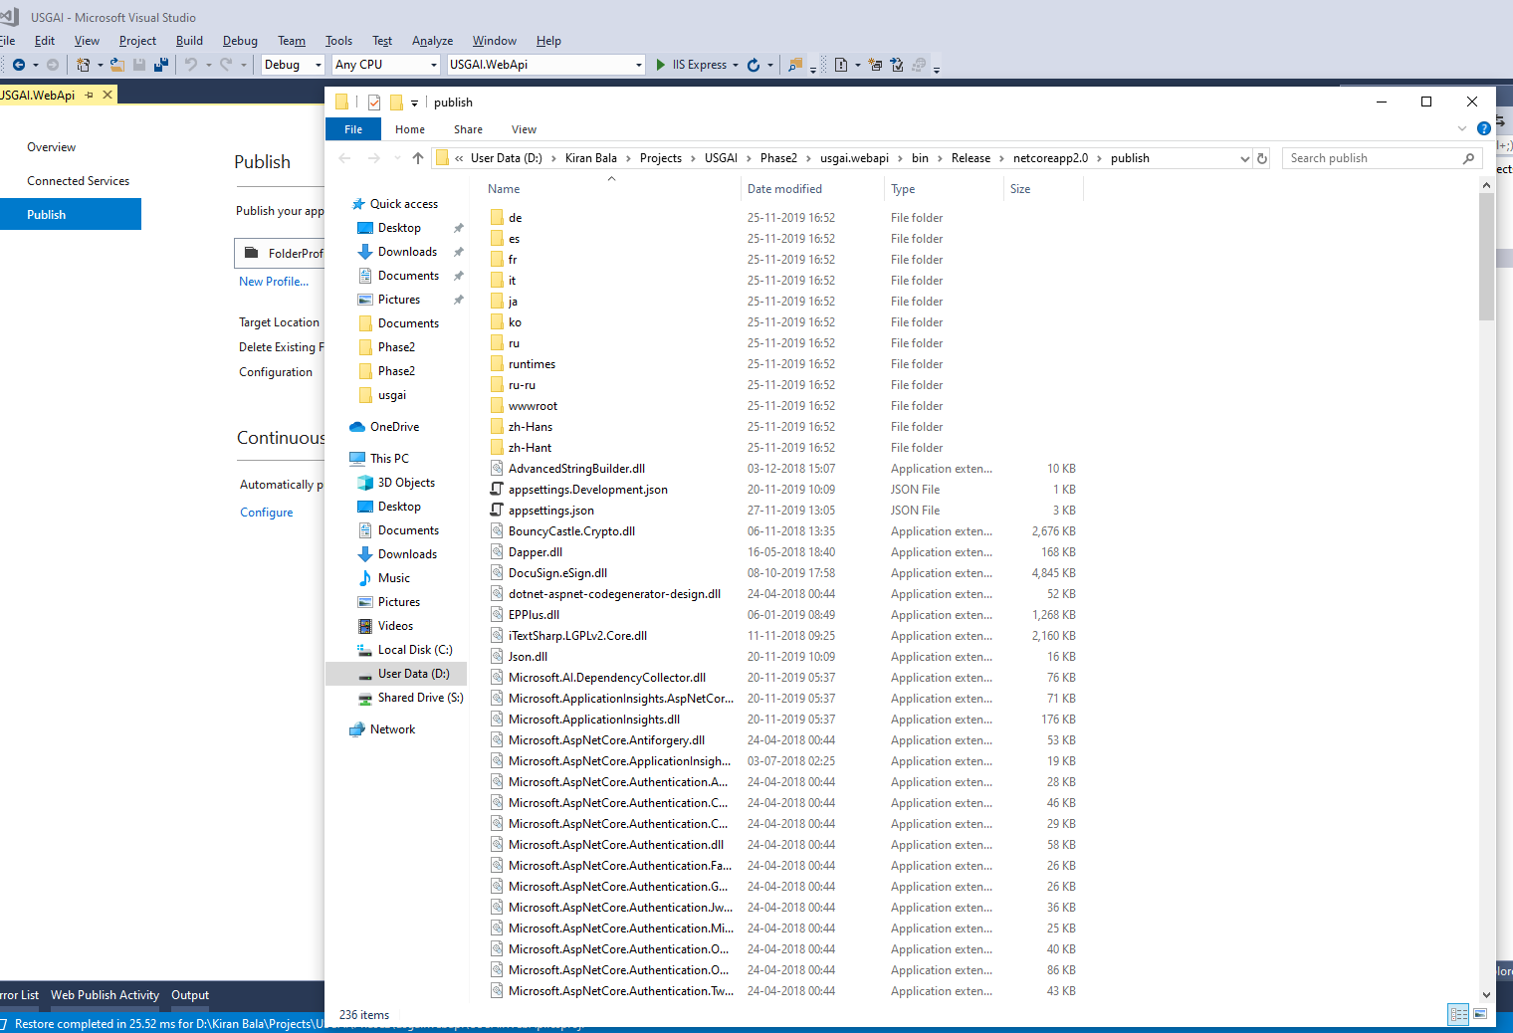

1. Test server folder of all Instances

Please get the Test server FTP detail from networks.

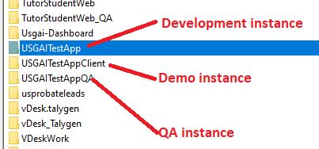

1. Connect the Test server ftp.  
   a. Keep Backup of Test server project  
   b. Select highlighted files and upload on root folder  
   c. check all the dll should upload properly. Check in Failed Transactions  
   If dll are failed to upload then delete all the dlls from Test srever and upload again.  
   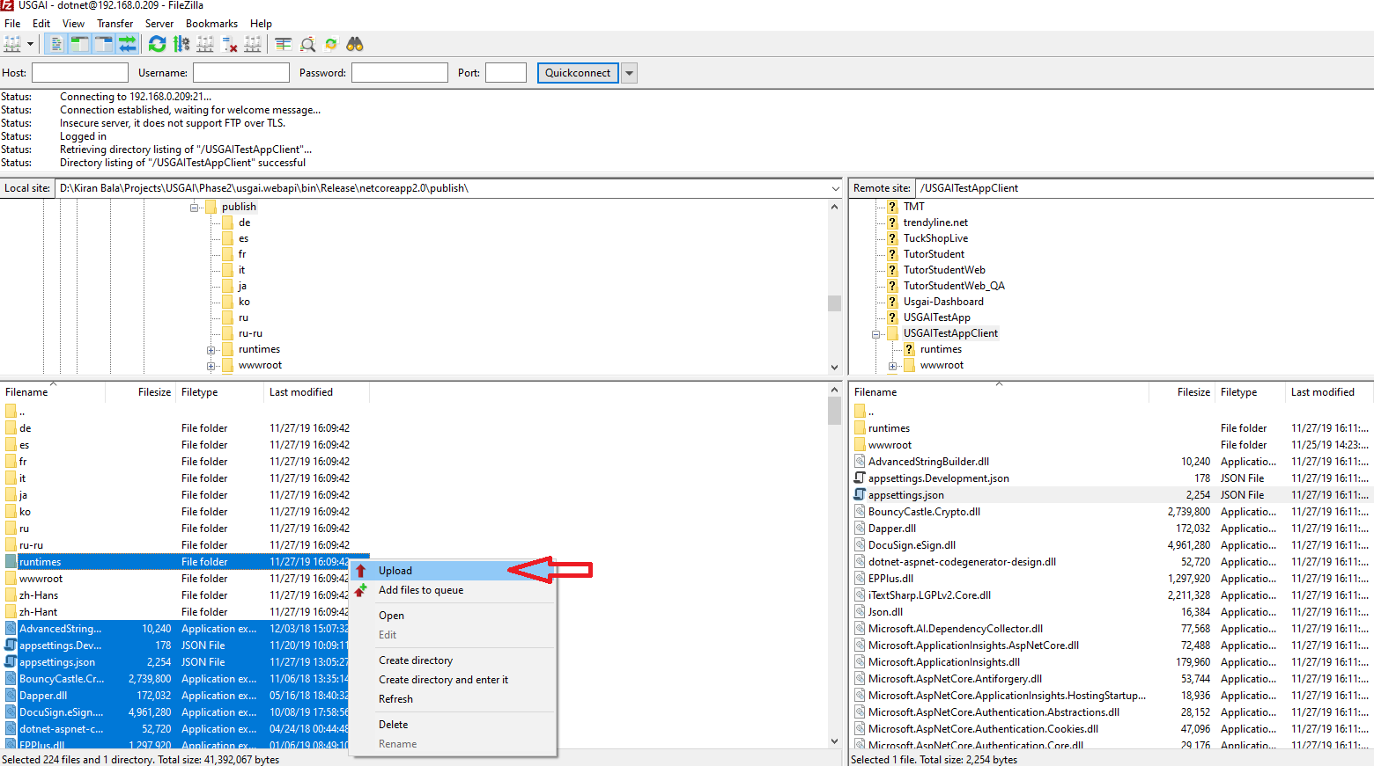

d. after uploading dlls in root folder. Now open wwwroot folder and upload all the files.  
 Do not upload src folder on Test server. If there is any folder you have created at local then create that folder manually.  
  
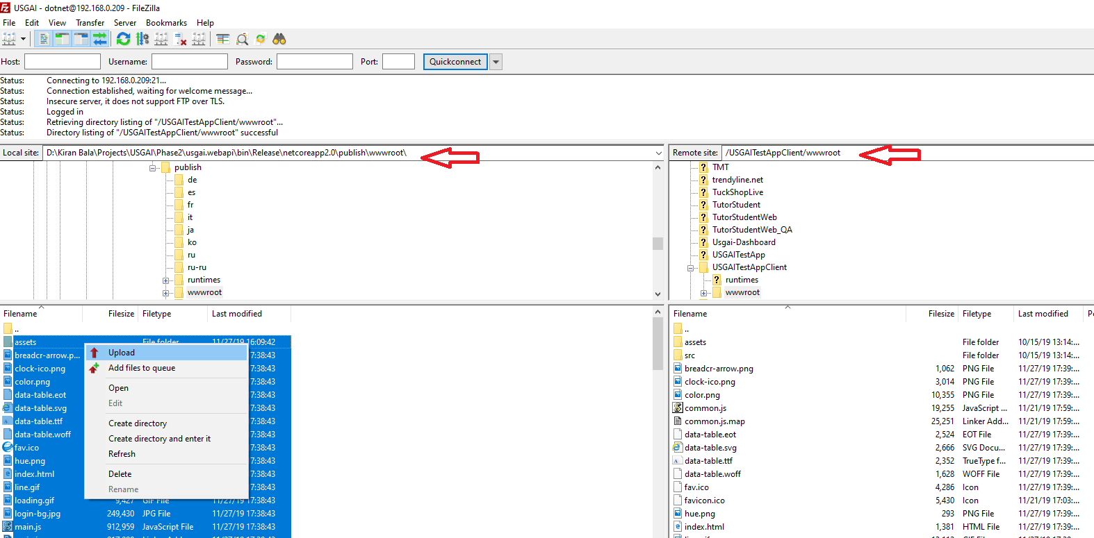

Database